Injection

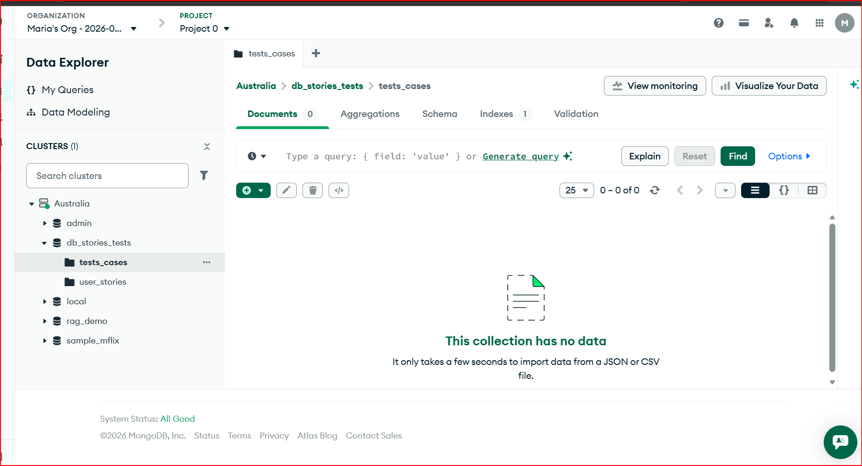

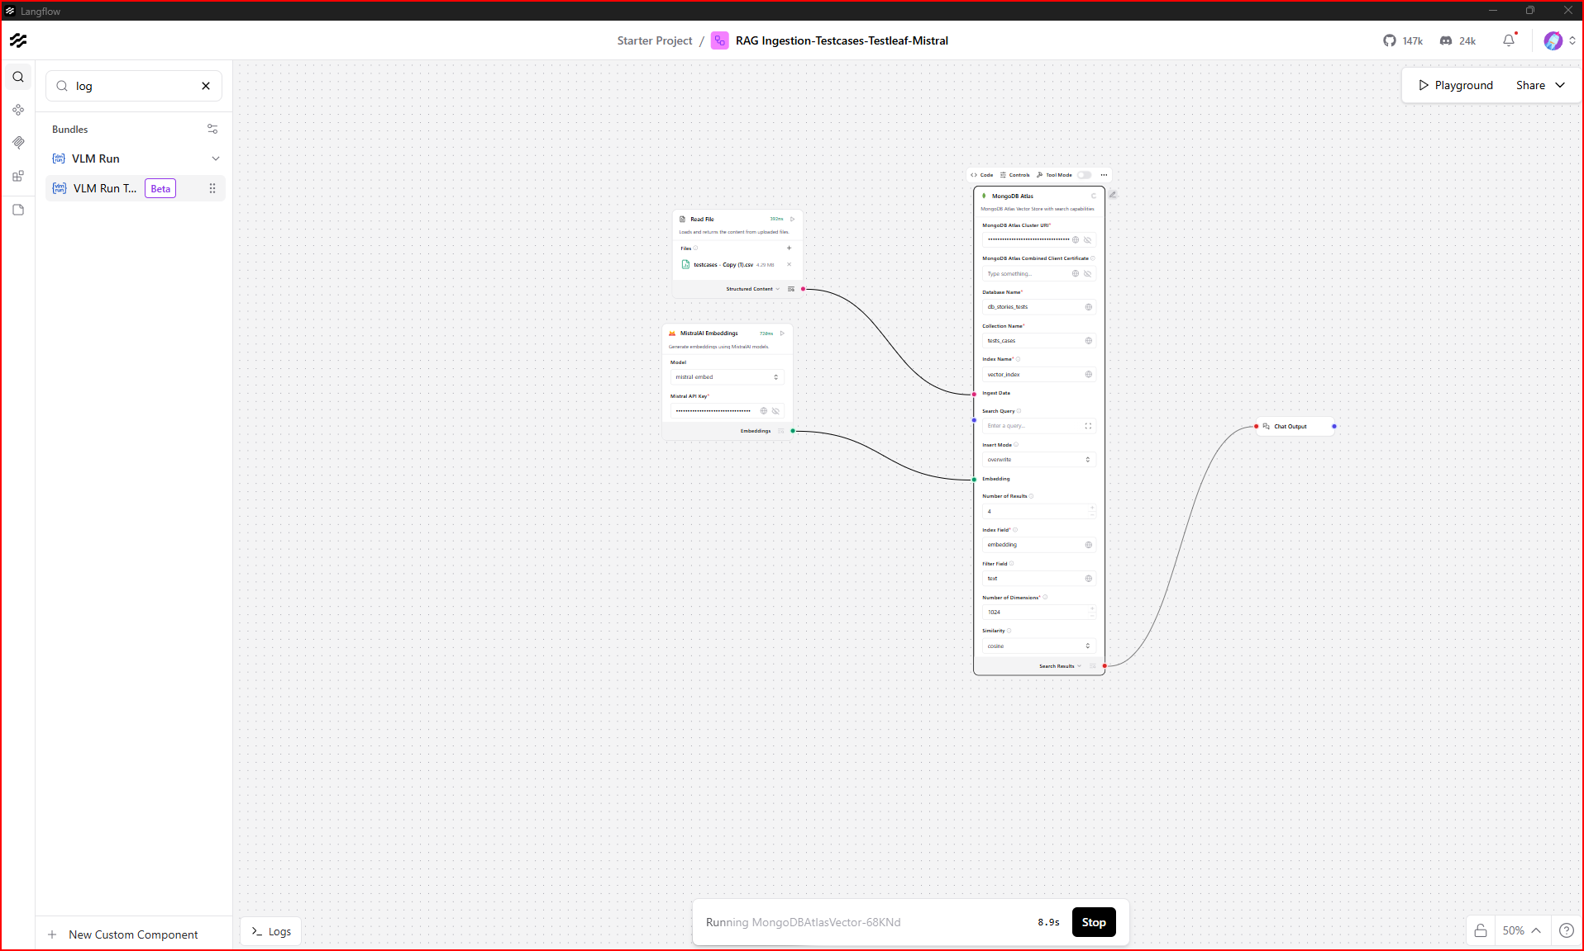
<script
src="https://cdn.jsdelivr.net/gh/logspace-ai/langflow-embedded-chat@v1.0.7/dist/build/static/js/bundle.min.js">
</script>
<langflow-chat
window_title="RAG Ingestion-Testcases-Testleaf-Mistral"
flow_id="6ff3b111-9125-4d6c-8e61-2d7770639965"
host_url="http://localhost:7860">
</langflow-chat>
<script
src="https://cdn.jsdelivr.net/gh/logspace-ai/langflow-embedded-chat@v1.0.7/dist/build/static/js/bundle.min.js">
</script>
<langflow-chat
window_title="RAG Ingestion-Testcases-Testleaf-Mistral"
flow_id="6ff3b111-9125-4d6c-8e61-2d7770639965"
host_url="http://localhost:7860">
</langflow-chat>
After injestion
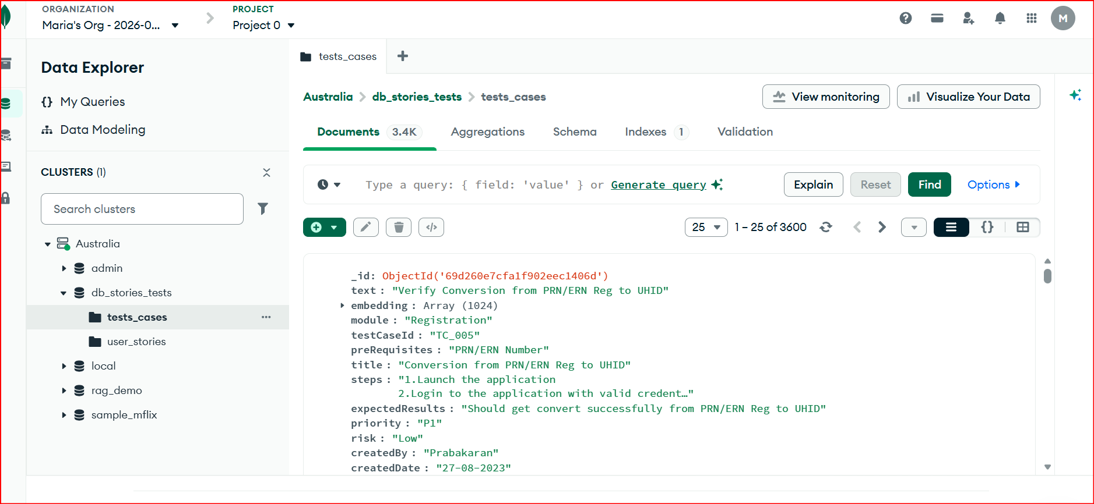
<script
src="https://cdn.jsdelivr.net/gh/logspace-ai/langflow-embedded-chat@v1.0.7/dist/build/static/js/bundle.min.js">
</script>
<langflow-chat
window_title="RAG Ingestion-Testcases-Testleaf-Mistral"
flow_id="6ff3b111-9125-4d6c-8e61-2d7770639965"
host_url="http://localhost:7860">
</langflow-chat>

